**1050 Programming Logic**

Lab 08 - Arrays

Name: __Connor Singerline_______

***Instructions:*** *Complete the following exercises. Push your code to github and share the URL to your repository by submitting it to Blackboard.*

1. Fill in the blanks in the following statement (2 points):

Given the following code, output the 2nd element (not index 2) and the last element.

string[] names = { "Al Dente", "Anna Graham", "Earle Bird", "Ginger Rayle", "Iona Ford" };  
ANSWER:  
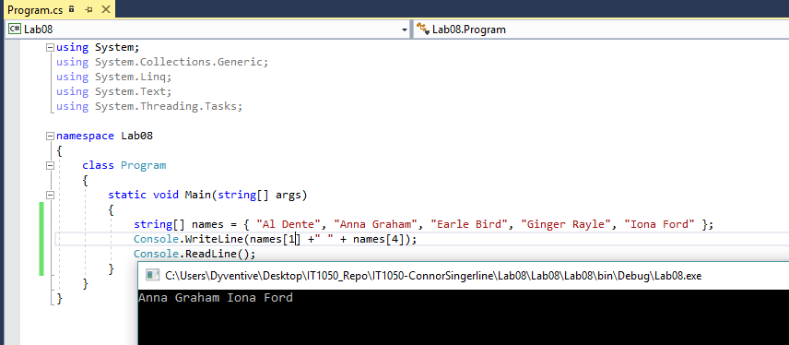

1. Create a 12-element array called months. Set each element to the name of each month.

For example months[0] = “January”. Use a for loop to display the number and name of each month. (4 points)  
ANSWER:

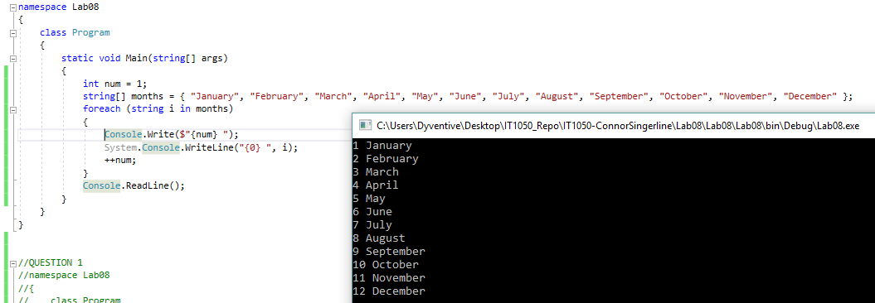

1. Create a 4-element array to store the names of 4 seasons. Use a foreach loop to display the name of each season. (4 points)  
   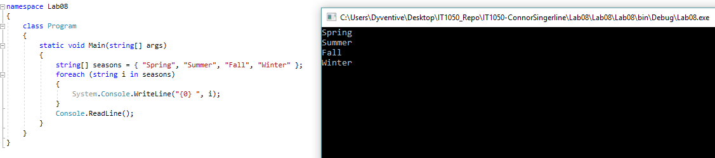
2. Create an array of integers with 1000 elements. Fill the array with random numbers. Use a foreach loop to print all integers in the array (4 points).

Random random = new Random();  
int randomNumber

randomNumber = random.Next(0, 100); // place this line in the loop

ANSWER:  
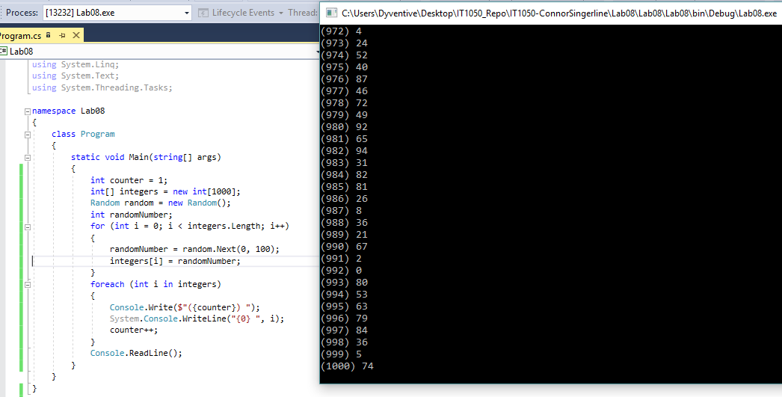

1. Paste the following code into the main() method. Modify the code; so that it works (You’ll have to make 2 small modifications). It should output the value of each string in the array called names (2 points).

string[] names = { "Al Dente", "Anna Graham", "Earle Bird", "Ginger Rayle", "Iona Ford" };

int i = 0;

while (i < names.Length)

{

Console.WriteLine(names[0]);

}

ANSWER:   
